Homework 3 Report

Question 1

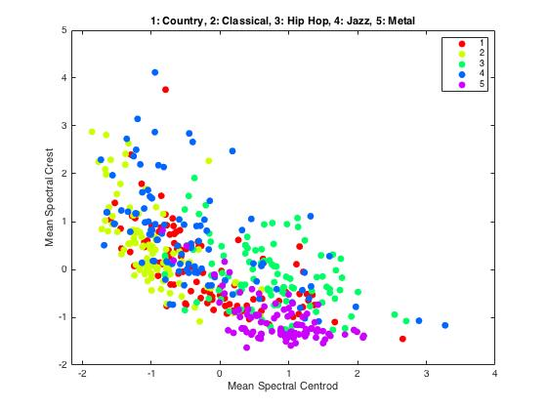

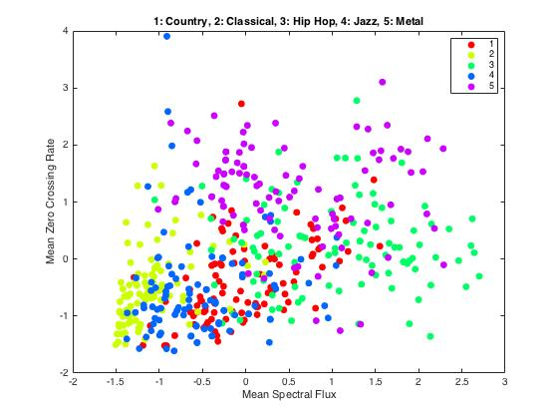

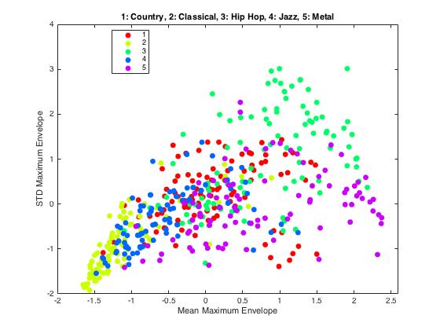

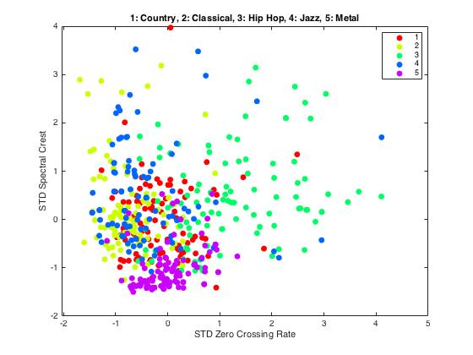

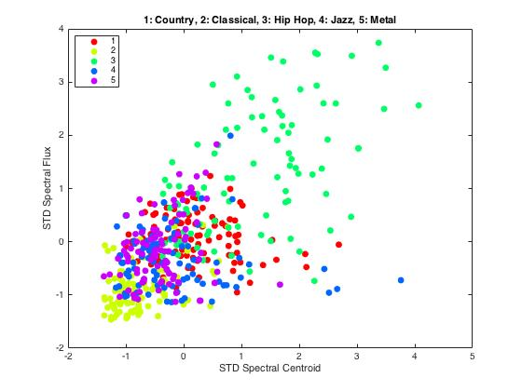

Clear class distributions show up when projecting onto each of these pairs of features. Some of these distributions are very overlapping, such as jazz and metal on the STD Spectral Flux vs STD Spectral Centroid. However, jazz and metal are easily separated on the Mean Spectral Crest vs Mean Spectral Centroid plot. In general, these plots are fairly promising in terms of class separability.

covariance =

1.0000 0.4861 0.5684 0.3302 -0.6762 -0.3826 0.8636 0.6828 0.5660 0.2697

0.4861 1.0000 0.3918 0.6208 -0.0391 0.2748 0.1739 0.8635 0.3127 0.5617

0.5684 0.3918 1.0000 0.7897 -0.4279 -0.2065 0.3748 0.4386 0.9751 0.6522

0.3302 0.6208 0.7897 1.0000 -0.1023 0.1708 0.0715 0.5426 0.7122 0.8868

-0.6762 -0.0391 -0.4279 -0.1023 1.0000 0.8525 -0.7962 -0.2795 -0.4710 -0.1744

-0.3826 0.2748 -0.2065 0.1708 0.8525 1.0000 -0.5728 0.1038 -0.2820 0.0901

0.8636 0.1739 0.3748 0.0715 -0.7962 -0.5728 1.0000 0.4922 0.4025 0.0797

0.6828 0.8635 0.4386 0.5426 -0.2795 0.1038 0.4922 1.0000 0.3594 0.4886

0.5660 0.3127 0.9751 0.7122 -0.4710 -0.2820 0.4025 0.3594 1.0000 0.6282

0.2697 0.5617 0.6522 0.8868 -0.1744 0.0901 0.0797 0.4886 0.6282 1.0000

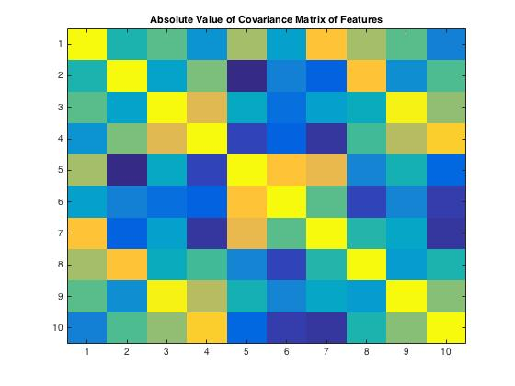

Feature Names:

1. Spectral Centroid Mean

2. Spectral Centroid Standard Deviation

3. Spectral Flux Mean

4. Spectral Flux Standard Deviation

5. Spectral Crest Mean

6. Spectral Crest Standard Deviation

7. Zero Crossing Rate Mean

8. Zero Crossing Rate Standard Deviation

9. Max Envelope Mean

10. Max Envelope Standard Deviation

High (absolute value of) covariance between features implies redundant features. Most features have fairly low covariance, but sometimes the mean and standard deviation of the same feature have a higher covariance (eg. Spectral Flux, Spectral Crest). Also, ZCR and Spectral Centroid have a high covariance, which makes sense because they are both (roughly) measures of the ratio of low-frequency energy vs high-frequency energy. Spectral Flux and Max Envelope also have high covariance, which makes sense because spectral flux is likely to be higher when the signal energy is higher.

Question 2

In the case that there are multiple majority classes (classes with the largest number of nearest neighbors), we compute the average distance per class and return the class with the minimum mean distance. When computing the K nearest neighbors, in the case that there are two points with equal distance, we choose the first one encountered and discard the other (if both won’t fit in the set of nearest neighbors). This really shouldn’t be too much of a problem: since many of our ten features are continuous valued, it is highly unlikely that two points will have the same distance.

Question 3

Evaluating Genre Classification System.

Class Names:

Class 1: Country

Class 2: Classical

Class 3: Hip Hop

Class 4: Jazz

Class 5: Metal

Feature Names:

1. Spectral Centroid Mean

2. Spectral Centroid Standard Deviation

3. Spectral Flux Mean

4. Spectral Flux Standard Deviation

5. Spectral Crest Mean

6. Spectral Crest Standard Deviation

7. Zero Crossing Rate Mean

8. Zero Crossing Rate Standard Deviation

9. Max Envelope Mean

10. Max Envelope Standard Deviation

\*\*\*\*\*\*\*\*\*\*\*\*\* K = 1 \*\*\*\*\*\*\*\*\*\*\*\*\*

Features ranked best to worst for K = 1:

4 3 6 1 7 8 10 5 2 9

Accuracy for K = 1: 0.746

Confusion Matrix for K = 1:

62 2 13 19 4

5 85 2 7 1

13 1 73 3 10

11 10 1 70 8

5 0 7 5 83

\*\*\*\*\*\*\*\*\*\*\*\*\* K = 3 \*\*\*\*\*\*\*\*\*\*\*\*\*

Features ranked best to worst for K = 3:

9 6 1 2 7 10 3 8 5 4

Accuracy for K = 3: 0.74

Confusion Matrix for K = 3:

68 1 10 18 3

8 82 1 8 1

17 0 73 4 6

15 10 3 62 10

6 0 4 5 85

\*\*\*\*\*\*\*\*\*\*\*\*\* K = 7 \*\*\*\*\*\*\*\*\*\*\*\*\*

Features ranked best to worst for K = 7:

3 6 5 8 2 1 10 4 7 9

Accuracy for K = 7: 0.734

Confusion Matrix for K = 7:

71 1 5 18 5

7 83 0 8 2

14 0 72 4 10

19 10 2 59 10

10 0 5 3 82

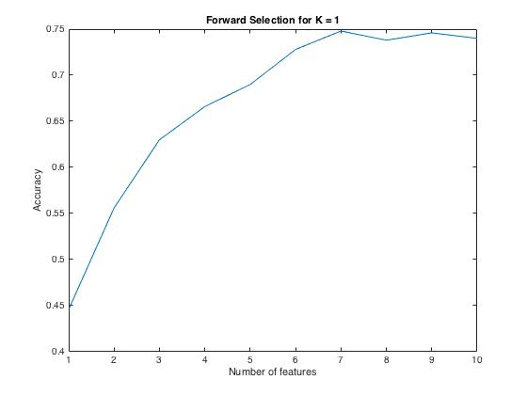

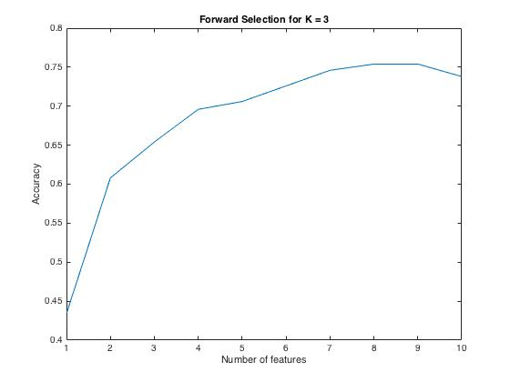

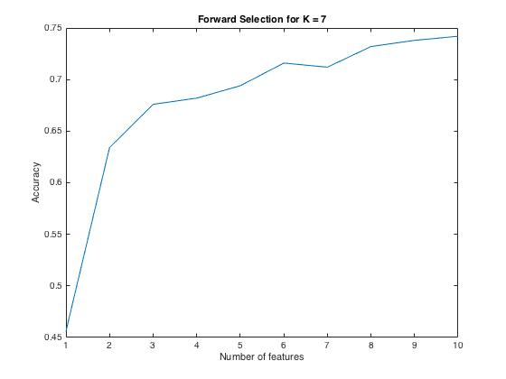

The country vs. hip hop and country vs. jazz genre pairs are both problematic (in both directions). There are also some mistakes made in classical vs jazz. Some jazz songs are predicted as metal. Country seems to be the most difficult to classify, and classical seems to be the easiest to classify.

Changing the K does not drastically change classification accuracy. In fact, multiple runs of the evaluation will result in different optimal K’s (randomized cross validation fold selection gives us different results). In this run, we can see that as K increases, the number of features that gives the best performance changes. Spectral Crest Standard Deviation (6), Spectral Flux Mean (3), and Spectral Centroid Mean (1) appear to be some of the best features.